USER REPORT

Fronius battery charging technology reduces intralogistics energy consumption at AMAG Austria Metall

Efficient charging across all weight categories

Wels, DD/MM/2015 – AMAG Austria Metall GmbH, Austria’s largest aluminium smelter, uses electrically powered forklift trucks to handle the internal flow of materials at its production site in Ranshofen. The largest trucks have a load capacity of twelve tonnes, which enables them to transport the huge aluminium plates. To reduce the electricity consumption of the fleet and comply with the latest energy efficiency legislation, the company opted for innovative battery charging systems from Fronius. These systems significantly reduce energy consumption and CO₂ emissions and also extend the service life of the expensive batteries.

The new energy efficiency legislation is currently a hot topic in every sector of industry. Since 2015, companies across Europe have been obliged to demonstrate that they are implementing specific measures to reduce their electricity consumption – either by carrying out regular audits or by introducing an energy management system. The objective is clear: becoming more efficient means increased competitiveness, which in turn protects the future of Europe as a manufacturing powerhouse. The environment benefits too, as the carbon footprint of the companies becomes smaller. However, the question that arises for the management teams, who generally speaking have already been working in a cost-conscious and sustainable manner for some time, is “how can I save even more energy?”

Energy management reduces consumption
“We use around 184 gigawatt hours of electricity a year,” notes Dr. Florian Stadler, head of energy management at AMAG Austria Metall GmbH. The company is Austria's largest aluminium smelter and a manufacturer of premium quality rolled flat products, high-precision cast plates and recycling cast alloys, all of which are manufactured at its plant in Ranshofen, Upper Austria, which also has a foundry and a rolling mill. Among the sectors using the finished products are the automotive industry, aerospace and shipbuilding, machine and plant construction, architecture, electronics and sports equipment.

To reduce its energy consumption as far as possible, AMAG operates an energy management system that is integrated into the company’s management system and is the responsibility of a dedicated department. “Our role is to take a critical look at our existing processes with a view to potential savings and to promote projects to improve our energy performance,” Stadler describes its brief. The company had its energy management system audited for the first time in 2013 and is now certified to the EU standard ISO 50001.

Plenty to do for the electric forklift truck fleet
The intralogistics operation at AMAG is modern and efficient: more than 150 electrically powered forklift trucks – from cleaning machines to lifting platforms, forklift trucks and tractor units through to heavy-duty frontlifts with load capacities of 12 tonnes – ensure a quiet, emission-free, speedy and reliable flow of materials. The fact that the plant operates 24 hours a day places severe demands on the performance and availability of load handling equipment. To avoid long downtimes, forklift trucks and tractor units in particular are equipped with back-up batteries: “When the capacity of a battery starts to get low, the driver goes to one of the many central charging stations, where he can replace it with a new one in a matter of minutes,” explains Stadler. The largest traction batteries, such as those used in the Hubtex lateral stacking trucks/sideloaders, weigh several tonnes and have to be transported using an indoor crane. With a nominal voltage of 80 volts and capacities of up to 1,000 ampere hours, they provide the energy required to lift and move the huge aluminium plates.

New charging process improves efficiency
The charging of the numerous traction batteries and the associated electricity consumption represents a not inconsiderable cost factor – a good enough reason for Florian Stadler and his team to examine the charging process very closely. It was while looking for optimisation potential that the managers at AMAG discovered Fronius battery charging systems. The technology leader is an Austrian company with headquarters in Pettenbach and has developed a new generation of chargers based around its innovative Ri charging process. With total efficiency levels of up to 84 percent, the chargers are considerably more efficient than conventional solutions and their gentle charging also extends the service life of the expensive traction batteries.

“The Ri charging process adapts itself to the age, temperature and state of charge of the individual battery,” explains Leopold Grammerstätter, technical consultant for battery charging systems at Fronius. “The losses at the start of charging and during the recharging phase are therefore much lower than with other charging technologies.” This lowers energy consumption, and hence costs, as well as reducing CO₂ emissions. The whole process is much gentler, as the battery does not heat up as much while it is being charged. “This means that the battery lasts longer and does not have to be replaced as frequently – another cost benefit,” observes Grammerstätter.

Fronius used the I-SPoT lifecycle costs calculator to determine the potential savings available to AMAG – with remarkable results: “We discovered that by using our chargers, the company can save more than 600,000 kilowatt hours of electricity a year,” reports Grammerstätter. “The indirect CO₂ emissions could be reduced by around 150,000 kilograms each year.” These compelling arguments clinched the deal: in 2014, Fronius supplied the first 20 Selectiva battery charging systems to AMAG via its sales partner Banner, and another 20 followed in 2015.

Photovoltaics and battery charging technology from a single source
The company made another investment back in 2013 with the aim of providing its intralogistics operation with low cost, sustainable levels of electricity: a photovoltaic system with an output of 40.8kWp was installed on a vacant plot on the company’s site. The four inverters, which since then have been generating environmentally friendly solar power, are also from Fronius. “Our long-term objective is a CO₂-neutral flow of materials,” explains Florian Stadler. “Although the solar power we are generating does not flow directly to the charging stations, we can feed it locally to our distributor and use it on site.”

The head of energy management is totally satisfied with the Fronius solution. His conclusion is that “the devices offer the most advanced technology on the market and help us achieve considerable savings – both in terms of electricity consumption and our carbon footprint”. The devices are thus an important factor as far as compliance with the stringent energy efficiency legislation is concerned. “At the same time they ensure that our forklift trucks are always available, even when working under such difficult conditions.” The new chargers have significantly improved the performance of the heavily worked traction batteries.

Characters: 7,183 (incl. spaces)

Image captions:

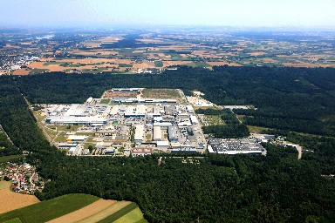 | Figure 1: AMAG Austria Metall GmbH is the largest aluminium smelter in Austria and a premium manufacturer of rolled flat products, high-precision cast plates and recycling cast alloys.
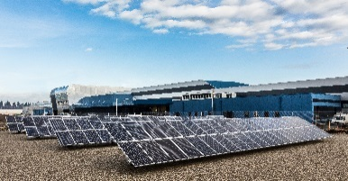 | Figure 2: Projects to improve efficiency are commonplace in sectors with high levels of energy consumption, such as the aluminium industry. AMAG installed a photovoltaic system on its site back in 2013.
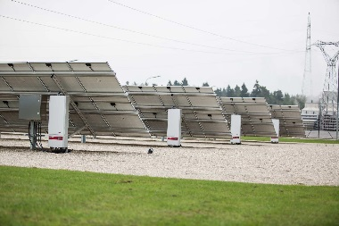 | Figure 3: The four inverters, which since then have been generating environmentally friendly solar power, are from technology leader Fronius.
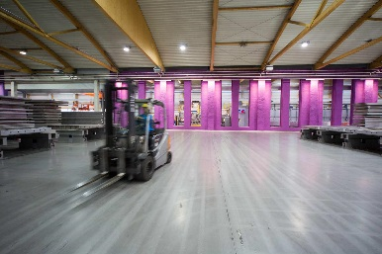 | Figure 4: More than 150 electrically powered forklifts – from forklift trucks to heavy-duty frontlifts – provide AMAG with a quiet, emission-free, speedy and reliable flow of materials.
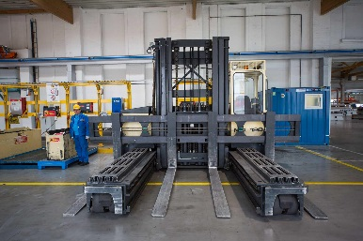 | Figure 5: Hubtex heavy-duty frontlifts are used to lift and move the huge aluminium plates.
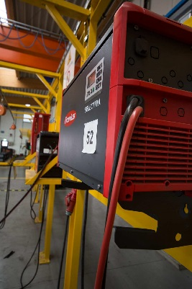 | Figure 6: Innovative battery charging technology from Fronius enables AMAG to save more than 500,000 kWh of electricity a year.
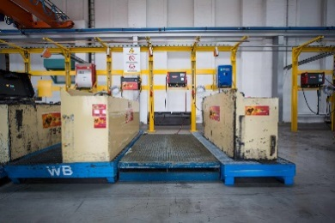 | Figure 7: The largest traction batteries weigh several tonnes, have a nominal voltage of 80 V and capacities of up to 1,000 Ah.
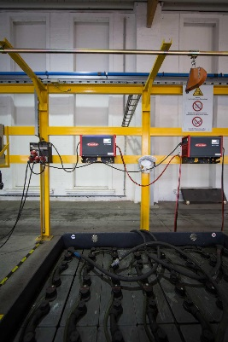 | Figure 8: The battery charging technology helps AMAG comply with recent energy efficiency legislation.
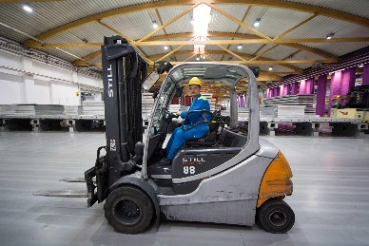 | Figure 9: The new chargers have significantly improved the performance of the heavily worked traction batteries.
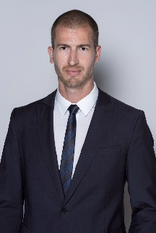 | Figure 10: “The devices offer the most advanced technology on the market and help us achieve considerable savings – both in terms of electricity consumption and our carbon footprint”: Dr. Florian Stadler, head of energy management at AMAG.

Copyright to photos: Fronius International GmbH, reproduction free of charge

Contact details for this publication:
Company name: | Fronius Perfect Charging
E-mail: | perfect.charging@fronius.com
Website: | www.fronius.com/intralogistics
YouTube: | www.youtube.com/FroniusCharging
Phone International: | +43 7242 2410
Phone UK & Ireland: | +44 1908 512347
Phone India: | +91 97654 98881

About Fronius International GmbH
Fronius International GmbH is an Austrian company with headquarters in Pettenbach and other sites in Wels, Thalheim, Steinhaus and Sattledt. With 3,723 employees worldwide, the company is active in the fields of welding technology, photovoltaics and battery charging technology. Around 90% of its products are exported through 24 international Fronius subsidiaries and sales partners/representatives in over 60 countries. With its innovative products and services and 838 granted patents, Fronius is the global innovation leader.

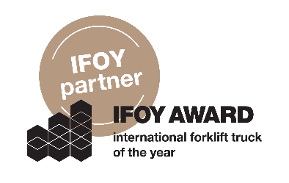 | Fronius is an official partner of the IFOY AWARD (International Forklift Truck of the Year), which recognises the best forklift trucks and application solutions in the industry, trade and service sectors.

Fronius U.K. Limited
Enquiries: Ross Adams, +44 7580 076988, adams.ross@fronius.com
Copies: Ross Adams, Maidstone Road, Kingston, Milton Keynes, MK10 0BD United Kingdom

Fronius India Private Limited
Enquiries: Dayal Varma Buddharaju, +91 97654 98881, buddharaju.dayalvarma@fronius.com
Copies: Dayal Varma Buddharaju, GAT no 312, Nanekarwadi, Chakan, Taluka- Khed District, Pune 410 501, India

a1kommunikation Schweizer GmbH
Enquiries: Kirsten Ludwig, +49 711 94541612, kirsten.ludwig@a1kommunikation.de
Copies: Kirsten Ludwig, Oberdorfstr. 31a, 70794 Filderstadt, Germany

