Press release
Perfect Charging

Fronius Perfect Charging facilitates sustainable charging of forklift fleets

Intelligent charging with solar energy

(Wels, April 2023) Charging forklift trucks with solar power and optimising self-consumption? This is now possible with a new function in the Charge & Connect portal from Fronius Perfect Charging. PV Connect helps the user to operate their forklift fleet intelligently and sustainably.

Rising electricity prices and increasingly strict environmental regulations demand cost-effective processes in intralogistics. Companies therefore need forklifts and AGVs that they can operate in a reliable and environmentally friendly manner. The cloud-based software solution Charge & Connect is Fronius Perfect Charging’s response to these challenges. The new function allows users to use self-produced solar energy to charge forklift trucks.

The feature, which combines efficient battery charging technology with a Fronius PV system, is called PV Connect. Instead of purchasing expensive energy from the grid via the energy supplier, the fleet operator can use their self-produced, renewable solar energy to charge their forklift fleet. The benefits are impressive, as anyone who uses the new function will reduce their energy costs whilst simultaneously contributing to greater sustainability in the company. “With this solution, we have ensured that intelligent charging is also sustainable,” stresses Patrick Gojer, Business Unit Manager Perfect Charging. “Customers also enjoy maximum availability of the forklift trucks and become more competitive.”

Sustainable at the touch of a button
What is possible with the new function? The user can control their self-consumption individually. PV Connect offers the user accurate weather and PV yield forecasts for this purpose. This allows the forklift operator to optimally plan and synchronise forklift battery charging with peak solar energy generation hours. Combined with the load balancing charging algorithm, the user can adjust their charging processes based on the availability of PV energy and specify when the self-generated energy will be used. The user also reduces load spikes and is no longer solely dependent on energy providers.

The customer can activate the function very easily by connecting their Fronius battery chargers with Charge & Connect, the photovoltaic system and the Fronius inverter. During configuration there is a choice between two options: PV-maximum makes maximum use of the PV energy available. Precisely as many batteries are charged as the PV power that is available allows. PV-optimum optimally adjusts the charging of the batteries needed to the PV energy available to increase the coverage ratio between power required and PV power.

2,721 characters incl. spaces

Images
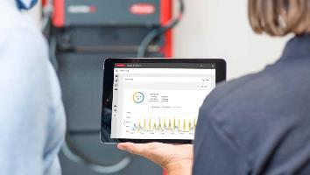
When combined with load balancing, the new PV Connect function can make optimum or maximum use of specially produced solar energy for charging the forklift fleet.

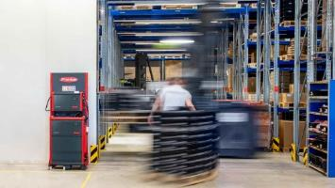
Anyone wanting to reduce costs for charging their forklifts and AGVs, whilst simultaneously achieving greater availability and flexibility, can use the new PV Connect function in the Charge & Connect portal. Fronius Perfect Charging uses solar energy for this solution.
Photo credits: Fronius International GmbH, reproduction free of charge

The high-resolution images are available for download here.

We are Fronius.
Over 7000 employees worldwide, a current export share of 89 percent, and 1366 active patents: that’s us, that’s Fronius. Founded in 1945 as a regional one-man operation, we are now a global player - a fact that is impressively demonstrated by our 37 international subsidiaries and our network of sales partners in more than 60 countries. And yet, at our core, we are still a family-owned company from Austria, active in photovoltaics, welding, and battery charging technology. We have always developed products and solutions for a future worth living, offering our customers an all-in-one package in the process: from advance planning and consulting to ongoing monitoring and a repair service tailored to their specific needs. We are innovative. We are curious. We are Fronius.

Contact details for this publication:

Company name: | Fronius Perfect Charging
E-Mail: | perfect.charging@fronius.com
Website: | www.fronius.com/intralogistik
YouTube: | www.youtube.com/FroniusCharging
LinkedIn: | www.linkedin.com/showcase/perfect-charging
Phone UK & Ireland | +44 1908 512300

For further exciting updates, follow us on LinkedIn (perfect-charging) and YouTube (FroniusCharging)!

For more information, please contact:
Fronius UK Ltd, Maidstone Road, Kingston, Milton Keynes, MK10 0BD

Natalie Woodford, +44 (0)1908 512 300, Woodford.natalie@fronius.com

Our agency:
a1kommunikation Schweizer GmbH,
Kirsten Ludwig, +49 (0)711 9454161-20, Kirsten.Ludwig@a1kommunikation.de
Oberdorfstraße 31 A, 70794 Filderstadt, Germany

